Czech Tour Report

I was lucky enough to have been invited to the JROS tour taking place in Czechia this summer. The camp began on the 12^{th of} August. I arrived in Prague at 9:00 before having a day of tourism around Prague whilst waiting for the other flights to land. We left Prague mid-afternoon and travelled 2 hours North to Potkarvarna, where we would be staying for the week. Once everyone had arrived at the accommodation, we had a briefing about the week ahead.
On our first day of training, we went to a local mountain area called Bramberk. We spent the morning training doing a few courses where we focussed on different features in the terrain. This was to help us get used to the area as we were not used to terrain like it. In the afternoon we did a relay on a zoomed in section of map. We were put into pairs and we each ran 3 courses.
The next day we went to a technical and complex sandstone area which was nothing like any terrain I had previously orienteered in. We spent the morning doing a range of courses. We did a route choice where we went round in fours, and we each did a route choice to find the fastest route in the terrain. I then did a control pick focussing on understanding the features in the control circle. In the afternoon we did a peg relay where if you got to a control with a peg, you’d take the peg then have to find a section of zoomed in map and run to those 4 controls before returning to the control to continue.
On day 3 we started with a line course where we followed a line through the intricate terrain. The aim being to stay in touch with the map and what was around you. We then did an interval exercise where you are in three’s each with a different map. Then we raced 4 legs and meet at a point for all people to get back together and then repeat 3 times. We had no training that afternoon but explored the sandstone features and went swimming in a river. In the evening we had a talk from JWOC 2010 winner Pavel Kubat who had recently planned the world cup long in Czech. That night we had a night orienteering course on the area above our accommodation.
On the 4th day we had a rest day, we did a micro course in the forest, which was followed by bilberry picking. We then went to a water park in the afternoon and went shopping in Liberec.
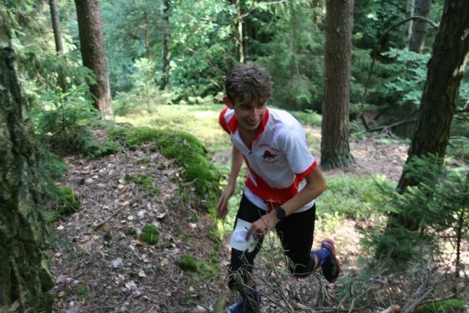
On our 5th day we went to the area used in WOC 2021. We did a few short courses and a route choice exercise in the morning. In the afternoon we did vampire orienteering which is a short score where you have to tag a card at each control you go to, but the vampires are able to swap cards if they catch you.
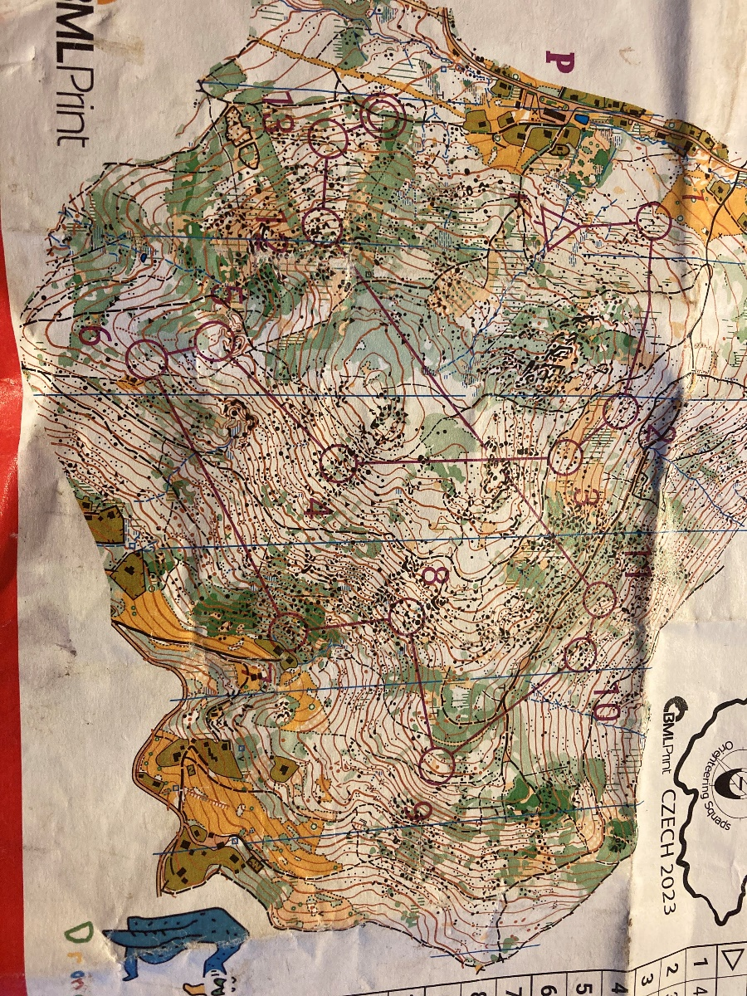
On the 6th day we had the tour champs middle. This was on a technical sandstone area. This was then followed by a couple of downhill courses near to the accommodation. The aim of these were to simulate orienteering on slopes, focussing on not dropping too low on your controls.
On our final day of orienteering, we had a tour champ long which was on a mountain area close to the accommodation. The tour champs are a way of consolidating what you have learnt during the week in a competitive situation. In the afternoon we ended by doing a micro event round the accommodation and grounds.
A massive thank you to all of the coaches who helped make this trip possible. Also, a big thank you to SWOA and Devon for their contribution to help cover the cost of my attendance.

