Deeside Report by Ben Perry (Devon M16)

At the start of the summer, I was lucky enough to be selected for the Deeside camp which is for bottom year 16’s. This year the tour wasn’t actually held at Deeside but rather at Findhorn. We all arrived at the accommodation late afternoon of the Saturday. On the Saturday evening we went through the plans for the week as well as getting to know all of the coaches and the other athletes.
On our first full day at Deeside, we started with a classroom session. We did these twice a day, once before the orienteering and another in the evening where we would reflect on the day as well as being given many techniques to improve our orienteering. On the first day we went to Culbin where we did a couple of talk-O courses to get used to the Scottish terrain. We also did some control pick courses working on picturing the control site.
On Day 2 we went to Darnaway in the morning where we did a range of compass exercises where we were working on taking bearings and picking features in the distance on our bearings. In the afternoon we went back to Culbin by boat to a less accessible area where we did a long style course.
On Day 3 we went to Roseisle where we did a map memory exercise where we were given a blank map with only the controls on, and a full map and we had to fill in the key features on the blank map to help run the coarse. We also did some more bearing exercises. Then, in the afternoon, we did another control pick course and a star relay.
On Day 4 we went to Lossie where we did a long legs course in the morning in which we had to adjust our technique due to the change in terrain from runnable forest to sand dunes then to green forest. In the afternoon we did a peg relay versus the Welsh squad who were also in the area.
On our final day of training, we did a middle-distance race at Darnaway which was the tour champs where we had to use all of the techniques we had learnt throughout the week. In the afternoon, after the tour champs, we did a course where we would stop every 3 or 4 controls and then swap maps with another person.
I had a fantastic week at Deeside and would like to thank SWOA and Devon for their support.

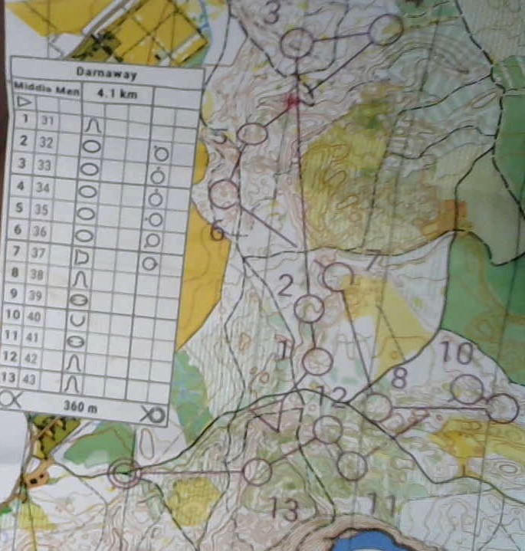
Some examples of some of the different exercise maps
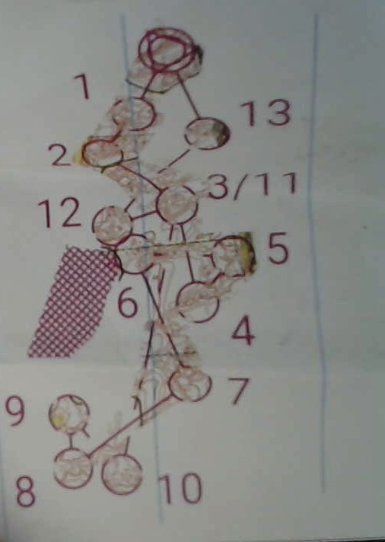

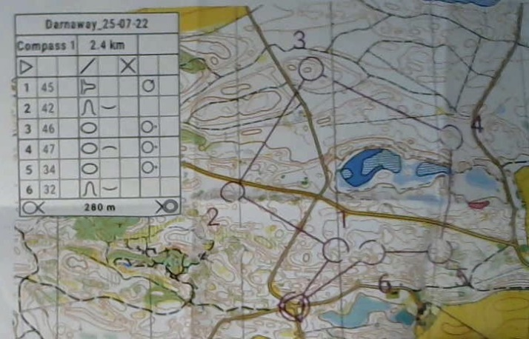
Compass exercise at Darnaway ^
Tour Champs course at Darnaway^
Compass exercise at Roseisle^

