Devon Orienteering Club
Woodbury Common
Orienteering for All!

Saturday 20th January & Saturday 17th February 2024

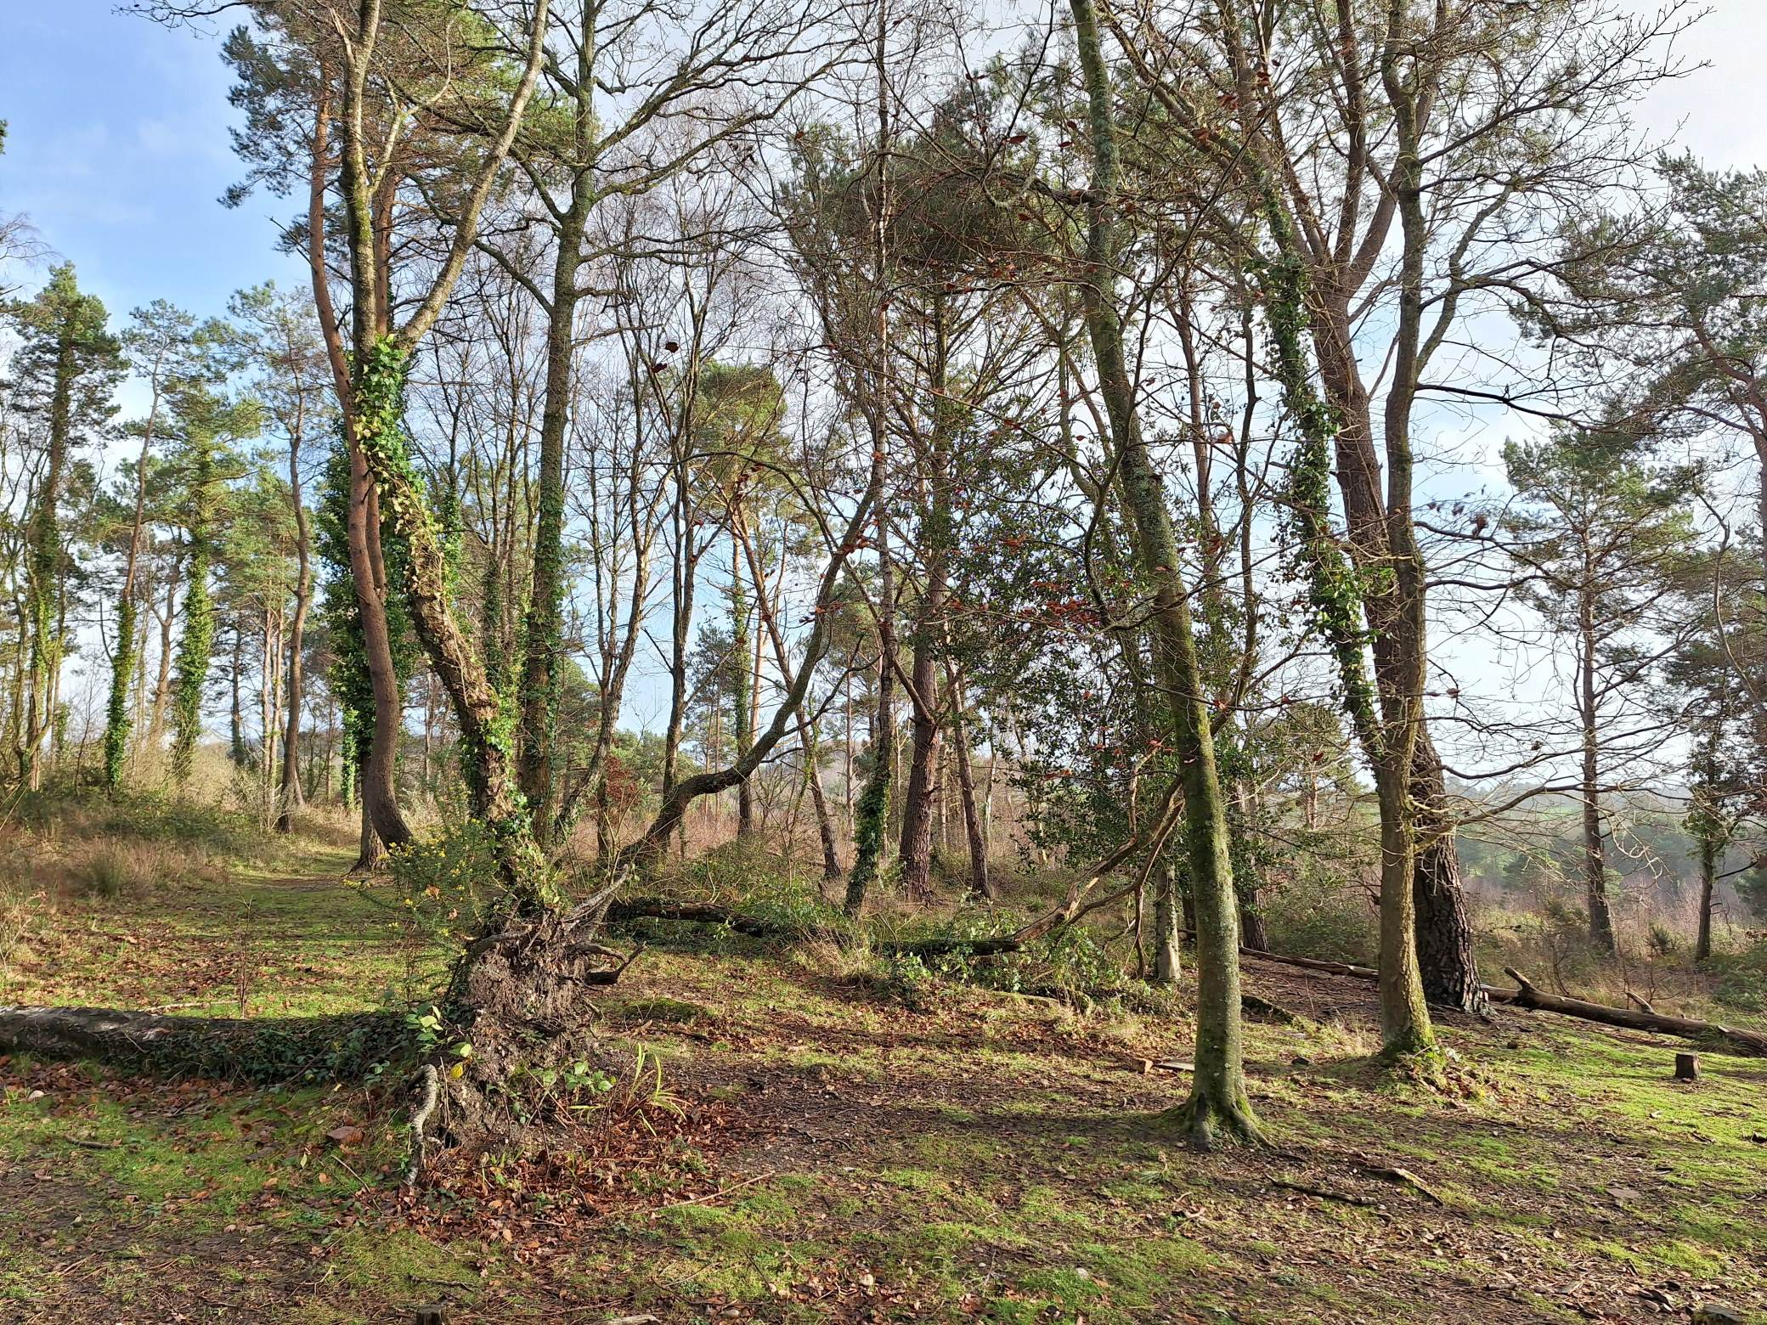

Come along for some informal (and free!) orienteering practice.
This is not just for beginners, all club members can benefit from some training without the pressure of being in a race.
Use these sessions as a warm up for Mutters Moor + the Compass Sport Cup heat at Bere Woods + Fernworthy

We'll be at Wheathill Plantation (What3words ///disarmed.obey.trackers) from 1030 to about 1200 (when we'll start collecting in the check points).
Bring a flask of tea and maybe a bit of cake to share for a post run a chit chat!

No need to book. For more information, contact Damian Wilson through:
https://www.devonorienteering.co.uk/contacts/club-coach

