DEVON ORIENTEERING CLUB
Haldon Forest
Orienteering
Coaching Session

Saturday 20th May 2023

9.30am – 11.30am
(Come along at any time within this time window for just 30 mins or the full 2 hours)

This is a free session aimed at matching your interest and experience of orienteering with some fun navigational practice!

Learn to orienteer if you are a complete beginner or improve your skills if you already have some experience.

All ages, individuals, groups / families welcome! No experience needed!

Doing the Park Run at 9am?
Then why not come along afterwards.

If you would like to attend this session please email Becca to let us know you are coming: mailto:coaching@devonorienteering.co.uk

Where: Haldon Forest Park EX6 7XR.
https://www.forestryengland.uk/haldon-forest-park

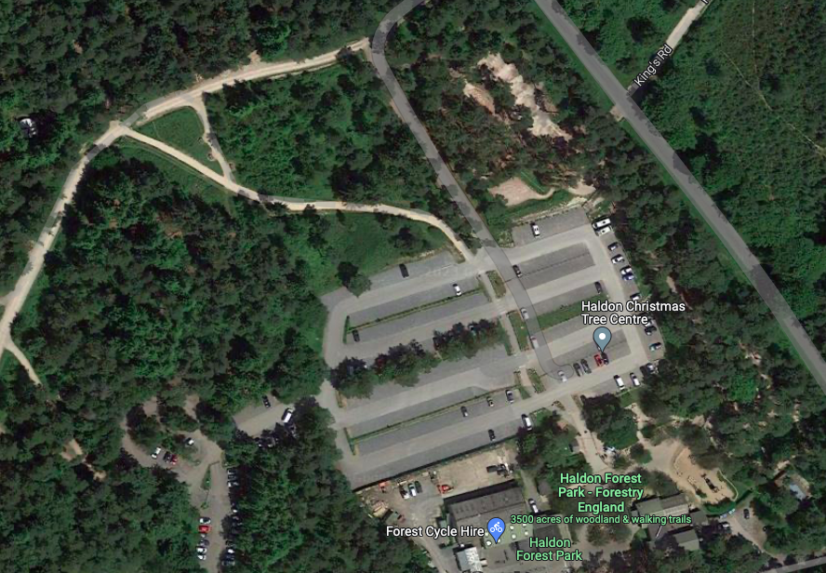
Orienteering Taster Session here
Find us by the picnic tables near to the car park entrance, on the way to the yurt.
Pay for Parking here

Follow this path from the parking area and you will find us

What to bring: Suitable footwear for walking / jogging on and off forest trails; please bring a compass if you have one (we can lend you one if not); weather-suitable clothing; water to drink.

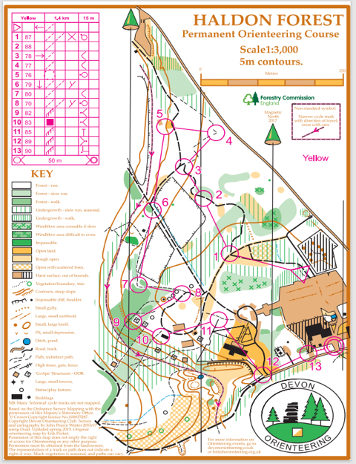
Example of a map & orienteering course:

Special offer: If you have already attended 2 sessions and this will be your 3rd session, we will give you free membership to Devon Orienteering Club and British Orienteering Federation!

Note: Children must be accompanied by a responsible adult.

Devon Orienteering Events: Can’t wait for the coaching session? Why not come along to one of our regular events? Please click on this link to find out what’s coming up: Events|Devon Orienteering

