DEVON ORIENTEERING CLUB

Haldon Forest
Orienteering
Taster

Saturday 18th February 2023

9.30am – 12.30pm
(Come anytime within this time window - just 30 mins or up to all 3 hours)

A free drop-in session aimed at matching your interest and experience with some fun navigational practice, and future orienteering opportunities.
(See: https://www.devonorienteering.co.uk/events)

All ages, individuals and groups / families welcome! No experience needed; we’ll teach you the basics.

Doing the ParkRun at 9am?
Then why not come along afterwards.

If you are interested in attending this or future sessions/events please email Becca: mailto:coaching@devonorienteering.co.uk for more information.

Where: Haldon Forest Park EX6 7XR.
https://www.forestryengland.uk/haldon-forest-park
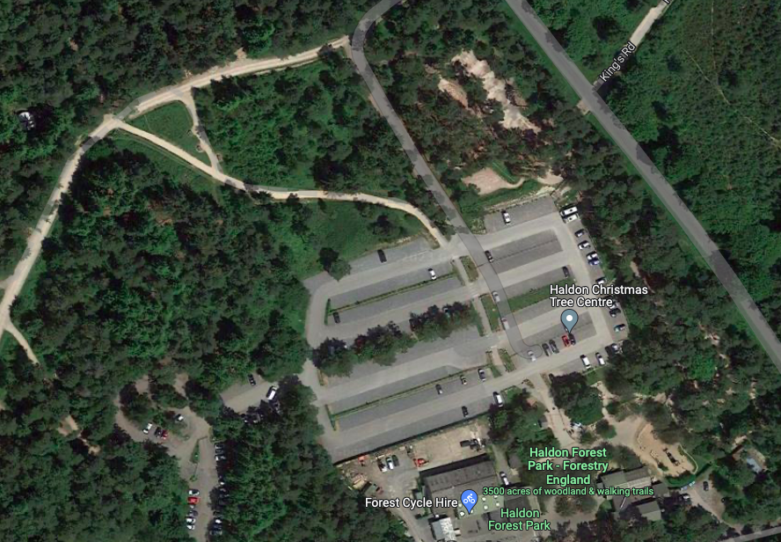
Follow this path from the parking area and you will find us

Orienteering Taster Session here

Pay for Parking here

What to bring: Suitable footwear for walking/jogging on and off forest trails; a compass if you have one (or borrow ours); weather-suitable clothing; water to drink.

Future Sessions: We expect to run more sessions in the spring, to help you build your skills further: Saturdays 15th, 22nd and 29th April, and 6th May.

Example of a map & orienteering course:
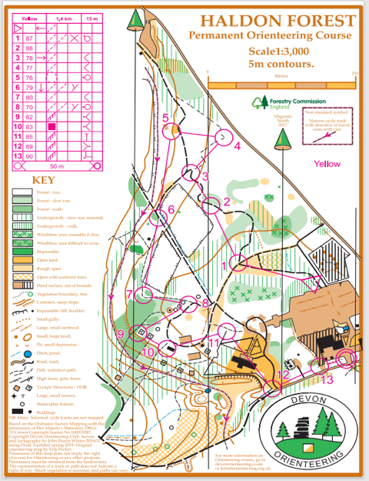

Special offer: If you attend 3 or more sessions, we will give you free membership to Devon Orienteering Club and British Orienteering Federation!

Note: Children under 16 must be accompanied by a responsible adult.

