World Schools’ Orienteering Championships in Otepää, Estonia
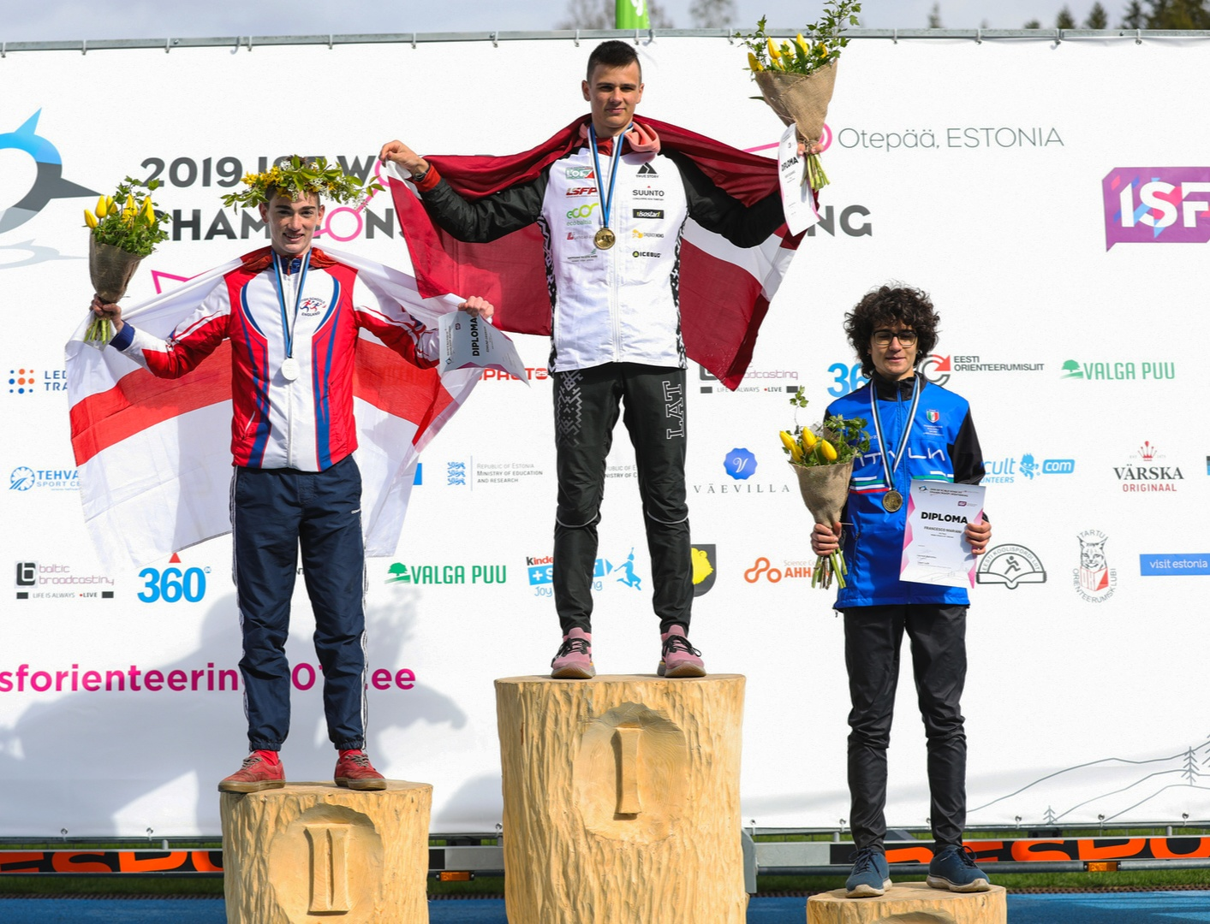
I wanted to report back on my orienteering year.

As you may know I was part of the M1 Select team that represented England at the World Schools’ Orienteering Championships in Otepää, Estonia a week ago. The competition was over three events a Long, a Middle and a Friendship Relay. The Long distance was the first race of the week. We spent the previous day gathering information about the style of the terrain on the model event. The terrain was mostly dense vegetation with lots of contour detail and a confusing path network. I decided that the fastest way to race the Long would be to go round on paths and then take a fine bearing in to the control circle. This was mainly because of how unrunnable the terrain was in places. My tactics worked and I was able to get round with minimal mistakes which secured me a 3rd place, only 38 seconds down on the leader. We then were given a rest day where we explored the nearby city of Tartu.

The Middle was the following day. I started my run poorly making a mistake at control 2 this put me over 40 seconds down on the winner. However, I was able to reduce the gap to 4 seconds by the finish and climb into 2nd position, 4 seconds behind the winner. The Friendship Relay followed the next day with sprint controls round the town of Otepää, as well as a few forest ones. Unfortunately, I was unable to repeat the previous day’s success as our team mispunched. For me the week provided an amazing experience of racing at international level over different terrain as well as the opportunity to meet lots of new people. My team achieved a first place overall. As you may also know the South West’s Jim Bailey and Oliver Tonge were part of my 5 boy team.efgb

