

Introductory
Planners’ Course

Payhembury
7th & 15th Nov 2018
19.30 - 22.00

John Pearce

The Club arranges Training Courses from time to time to help Club Members take on new roles within the club.

John Pearce is one of the team of hard-working mappers in the club. They constantly revise existing maps to capture changes in vegetation or make more significant updates. Also, from time to time, they make “new maps” of areas previously unmapped for orienteering.

John also has pretty shrewd ideas about course planning.

Obviously every event needs a Planner. This two-part course is designed to enable club members, with orienteering experience, to take on this role for one of the events in our Fixtures Program. As a first-time event planner, you would certainly be supported by a Controller/Mentor to guide you through the process.

Date Wed 7th November and Thurs15th November 2018, 19.30 – 22.00. Note Wed then Thurs
Venue Payhembury Parish Hall, 7km west of Honiton, EX14 3HT
If there is time for a “quick one” afterwards, the pub is adjacent.

Many thanks to Tom McMurtrie for booking the hall, and to John for agreeing to tutor the course.

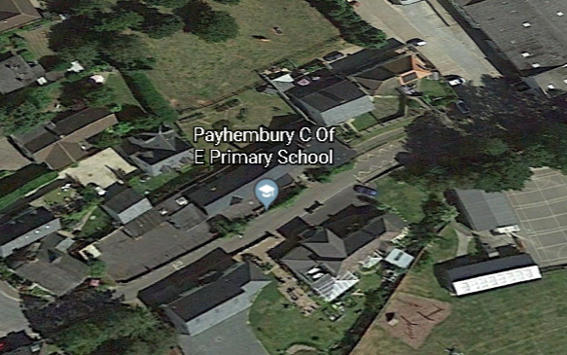

Members of other SWOA clubs are most welcome.

Please contact me if you wish to come. alanjsimpson16@gmail.com,
01364 654167 or 07754 086828
Please address questions about the course to John johncarolpearce@hotmail.com
01395 443813
Course Overview

These two sessions are aimed at those of you who have not planned before or have limited experience and wish to develop your skills. If possible, you should bring laptops with PurplePen (or Ocad CS) loaded. Preferably you should have tried these out first, as I will not spend much time in how to work them. Pencils and rubber might also be useful, and a memory stick.

The first evening will deal with 'pre-planning'; will then go through the Guidelines with the help of the 'BOF planning course' material; look at 'on the day' jobs; before doing some exercises. There will be homework!

The second evening will be more practical with lots of hands-on exercises.

John Pearce

References

Planning Principles (on the British Orienteering Website)

https://www,britishorienteering.co.uk – Get Involved – Resource Library - Planning

a) Practical Guidance – Hilary Quick

b) Appendix B to the Rules of Orienteering

c) Advice on Planning – Barry Elkington M60, 5 files covering TD1 – TD5 Read these first

d) TD Levels – Carol McNeill, W70 – the same thing written by one of the UK’s most illustrious competitors/coaches

Purple Pen

Purple Pen for Planners – Neil Crickmore DVO
http://www.derwentvalleyorienteers.org.uk/committee/Purple%20Pen%20for%20Planners.pdf

Using Purple Pen V1 – Neil Crickmore A more detailed document

Download the program (app) from www.purplepen.golde.org
It is free. You are invited to make a donation, but this is something the club will do.

We will bring some club computers, with Purple Pen on board, to the sessions, to help get you started.
Obviously we hope you will do the homework on your own machines.

