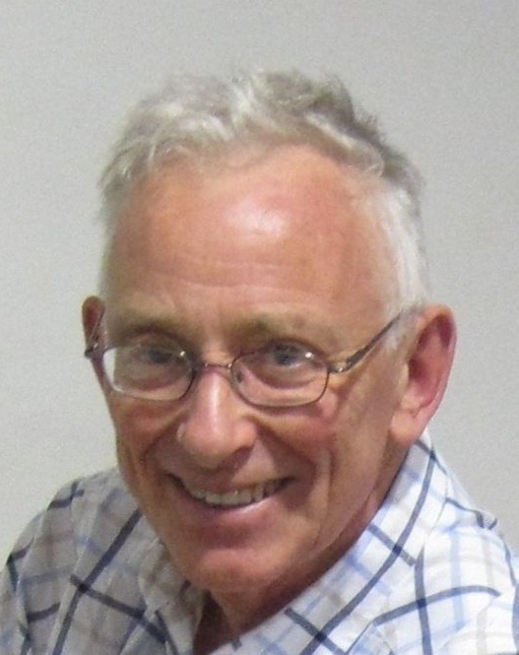


Organising a Big Event National (B) Level

Alan Simpson

Date Wed 20th March 2019
Time 19.30 – 21.30
Venue Ilsington Village Hall, 3km ESE of Haytor Rocks, SX 787761 or TQ13 9RG
In the photo, the hall is shown as the Village Shop. Note the good car park to the south and east of the hall
Host Rob Parkinson of DEVON OC, who lives in Ilsington and manages bookings for the Hall

Tea, coffee and biscuits will be available from 7pm. Note also the Carpenter’s Arms. After the course, some of us may pop across the road for a “quick one”

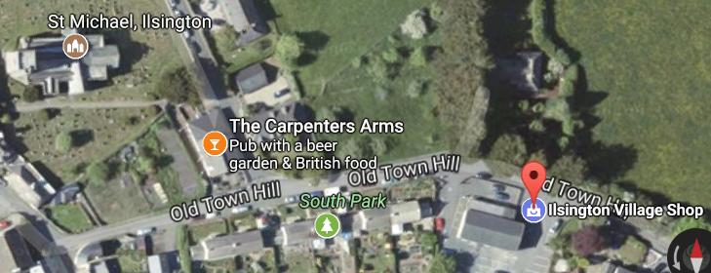

It is assumed that course participants will have some experience of organising Level C Regional events. So you know the “nuts and bolts” of the process. I shall hopefully be giving you some tips on how best to put them together, and the extra expectations as you go up an event level.

If you have any queries, please feel free to contact me on 01364 654167, 07754 086828, or alanjsimpson16@gmail.com
Also contact me to book a place on the session.

The course content will essentially be a case study of the Tamar Triple 2018, for which I was overall Co-ordinator.
Each of the three days had separate day organisers.

In the build up to that event last year, for internal communication purposes within the organising team, I set up a folder on Dropbox entitled TT2018. The folder is still sitting there “in the cloud”. I will send an invitation to anybody wishing to attend this course. This will enable you to gain access to this folder, and indeed it will be the pre-course reading for you.

There are also selected BOF documents.

Key Concepts in no particular order KISS
to bear in mind when organising Delegation
T The Devil is in the Detail PTO Breakout Session

Also Damian Wilson, co-planner for the Braunton Middle Race, has kindly agreed to bear his soul, and talk about|:-

“The Angst of a Jury Activation” PTO
Breakout Session – Themes for Discussion

Please elect a leader for each group, who will report back afterwards

1) Publicity and Finance What length of time ahead do you need to start planning?

Is there any significant benefit in having a dedicated website?
(Pre-session homework – look at the big multi-day events. Scottish 6 Days, Lakeland 5-days
Welsh Five-days, and Tamar Triple)
How do you best utilise your club website ?

Are printed flyers worth the effort?
How significant is Social Media?

Who sets the entry fees – the Organiser of the Club Committee? Is it worth having an early cheap rate?

2) Personnel How many Team Leaders do you need?
How many Helpers do you need?
To what extent is it feasible to adopt my preferred two-shift system?

3) UKUL and UKOL If you achieve UKUL/UKOL status, what impact will this have?

4) Managing the Start Turn up and Go, or
Pre-allocated half-hour blocks, or
Exact pre-allocated individual start times

Do you need a punching start for helpers in all cases, even the last?
What about EOD?

5) Communications Discuss my use of Dropbox

