
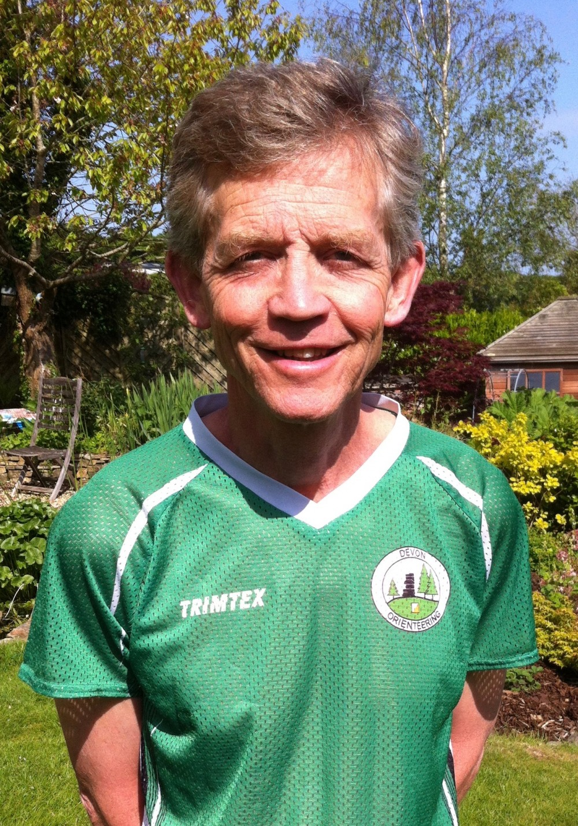
Post-Race Analysis

5th December 2018
7.30 - 9.30 pm
Ilsington Village Hall

Rob Parkinson

Most of us grieve over the time we lose getting lost, or making poor route choices. Discussing route choices is a great way to learn from our mistakes! This social event is intended to help you learn how to reduce errors, by reviewing route choices at some recent events. The objective of the evening session is then to help you improve your orienteering skills, and reduce errors at future events.

The intention is to focus on recent DEVON OC events, held on moorland and forest terrain
1) 4th March Fernworthy
2) 14th October Golden Dagger Galoppen
3) 25th November Holne Moor

Links
1) https://www.devonorienteering.co.uk/events/fernworthy-devon-moorland-league-event-4-mar-25-2018
2) https://www.devonorienteering.co.uk/results

There are two excellent computer applications for analysing “what went wrong for particular runners”, and studying how the experts do it - which Rob will demonstrate.

SplitsBrowser: Displays courses one by one in graphical format and shows very clearly your overall speed against others on your course, and legs where you lost time.

RouteGadget: Competitors send in the routes they took over the ground, either by estimating their legs on the map point by point, or by downloading their route from a wrist-mounted GPS tracker.

Here is a screen shot from RouteGadget showing two runners on part of the brown course at the recent Golden Dagger event.

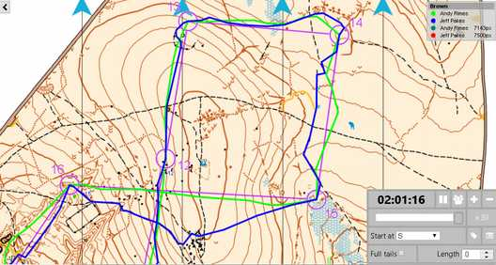

Depending on how the time goes, and numbers attending, we will probably move to a computer session where, working in pairs, you can explore these applications. Bring your laptop if you wish, the hall has Wi-Fi. Refreshments will be provided, and we will adjourn to the Carpenters Arms at the end of the evening.

Venue Ilsington Village Hall, 3km ESE of Haytor Rocks. Grid ref SX787761 or TQ13 9RG. In the photo below, the hall is the building linked to the Village Shop. The car park is behind (to the south) of the hall.

Date Wed 5th December 2018, 19.30 – 21.30

Many thanks to Rob Parkinson, who also manages the Hall, for organising the venue.

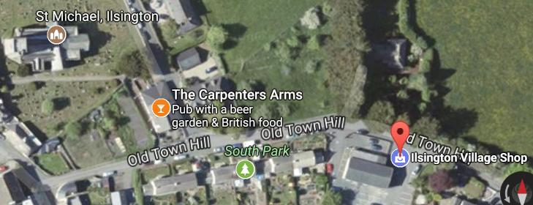

Booking a place, and enquiries
Please email Rob - rob@stonebarrow.plus.com

Beforehand: You will find links to SplitsBrowser and RouteGadget on the DEVON OC website, adjacent to the Results for these events. Try plotting your route online with RouteGadget, or even draw your route on a map (if you can remember where you went!)

Alan Simpson
Training/Clubnight Organiser

