

SI Team Workshop

3rd October 2018
19.30 - 21.30

Alan Simpson

We purchased the Sportident Electronic Timing Hardware eleven years ago, and it has served us well.
I look after the controls, stakes, flags etc, ie the SI kit needed by event planners.

The SI Team is a group of club members who run the computer system at each event, using the program “AutoDownload” which was written and maintained by Alan Hartley of Sportident.uk.

We have workshop training sessions from time to time. The purpose of this session is to
a) update existing members on the forthcoming switch from AutoDownload to SITiming
b) encourage some new people to join the group.

Date Wed 3rd October 2018, 19.30 – 21.30
Venue Ilsington Village Hall, 3km ESE of Haytor Rocks, SX 787761 or TQ13 9RG
In the photo, the hall is shown as the Village Shop. Note the good car park to the south and east of the hall.

Many thanks to Rob Parkinson, who manages the Hall, for providing the venue.

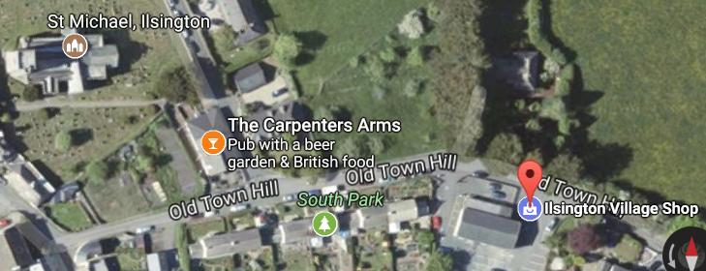

Most SI Team members have AutoDownload installed on their home computers, and it is a straightforward task to add SITiming alongside. The difficult stages in the installation, namely loading the Miscrosoft SQL Server, and software drivers for the Master Station and Splits Printer need not be repeated.

I have been installing SI Timing on the club computers, and it only takes a few minutes.

Existing Team Members
I hope all existing SI Team members will be able to attend, and bring their computers with them.

New Members
Please come along and find out what it is about.

All
Please contact me if you plan to come. alanjsimpson16@gmail.com, 01364 654167 or 07754 086828

PTO Practical Tasks
Equipment

Half a dozen computers, with SI Timing installed.
3 Master Stations
2 Splits printers

New document – Beginner’s Guide to SI Timing, Alan Simpson

xml course file with 3 courses
6 competitors, A – F, ie 6 dibbers with punches ready for dibber registration and download
6 Registration forms
Check box with 6 records

Tasks

Set up event
Enter competitors using dibber entry (entry by punch) for A, B, and C, and manual entry for D, E, and F
Download the dibbers
Print results on splits printer
Confirm that all competitors have returned

Trip-wires

One incorrect dibber number on a registration form
One competitor running the wrong course
One competitor who failed to punch the Start

Use of DropBox

We use Dropbox as a sort of private website, where membership is by invitation only, like a Gentlemen’s Club.

I keep a copy of the Devon OC Fixture List on it, with three extra columns for the SI Team, entitled SI Team Leader and SI Assist, SI Assist.

Each event has an SI Team Leader for the day, and normally a two-shift system operates with two people on the first shift and one on the second. Using Dropbox enables people to volunteer for these tasks, just by opening the file and writing their name in the appropriate box. Theoretically I need do nothing to find volunteers!

